Benha University  Faculty of Engineering at Shoubra  Electrical Engineering Department |  | Microwave fundamentals  3rd Year Communications  (2013-2014)

Sheet 3

$\boxed{1}$ Use the Smith chart to find the following quantities for the transmission line circuit below:
- The SWR on the line.
- The reflection coefficient at the load.
- The load admittance.
- The input impedance of the line.
- The distance from the load to the first voltage minimum.
- The distance from the load to the first voltage maximum.
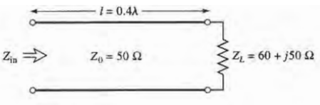
$\boxed{2}$ Repeat problem (1) for Z_{L}= 40 - j30Ω. (REPORT)
$\boxed{3}$ Repeat problem (1) for 𝓁= 1.8λ. (REPORT)
$\boxed{4}$ Use the Smith chart to find the shortest lengths of a short-circuited 75 Ω line to give the following input impedance:
(a) Z_{in}= 0.
(b) Z_{in}= ∞.
(c) Z_{in}= j75 Q.
(d) Z_{in}= -j50 Ω
(e) Z_{in}= j10 Ω.
$\boxed{5}$ Repeat Problem (4) for an open-circuited length of 75 Ω line. (REPORT)
$\boxed{6}$ A slotted-line experiment is performed with the following results: distance between successive minima = 2.1 cm; distance of first voltage minimum from load = 0.9 cm; SWR of load, = 2.5. If Zo = 50 Ω, find the load impedance.
Good Luck
Dr. Gehan Sami

